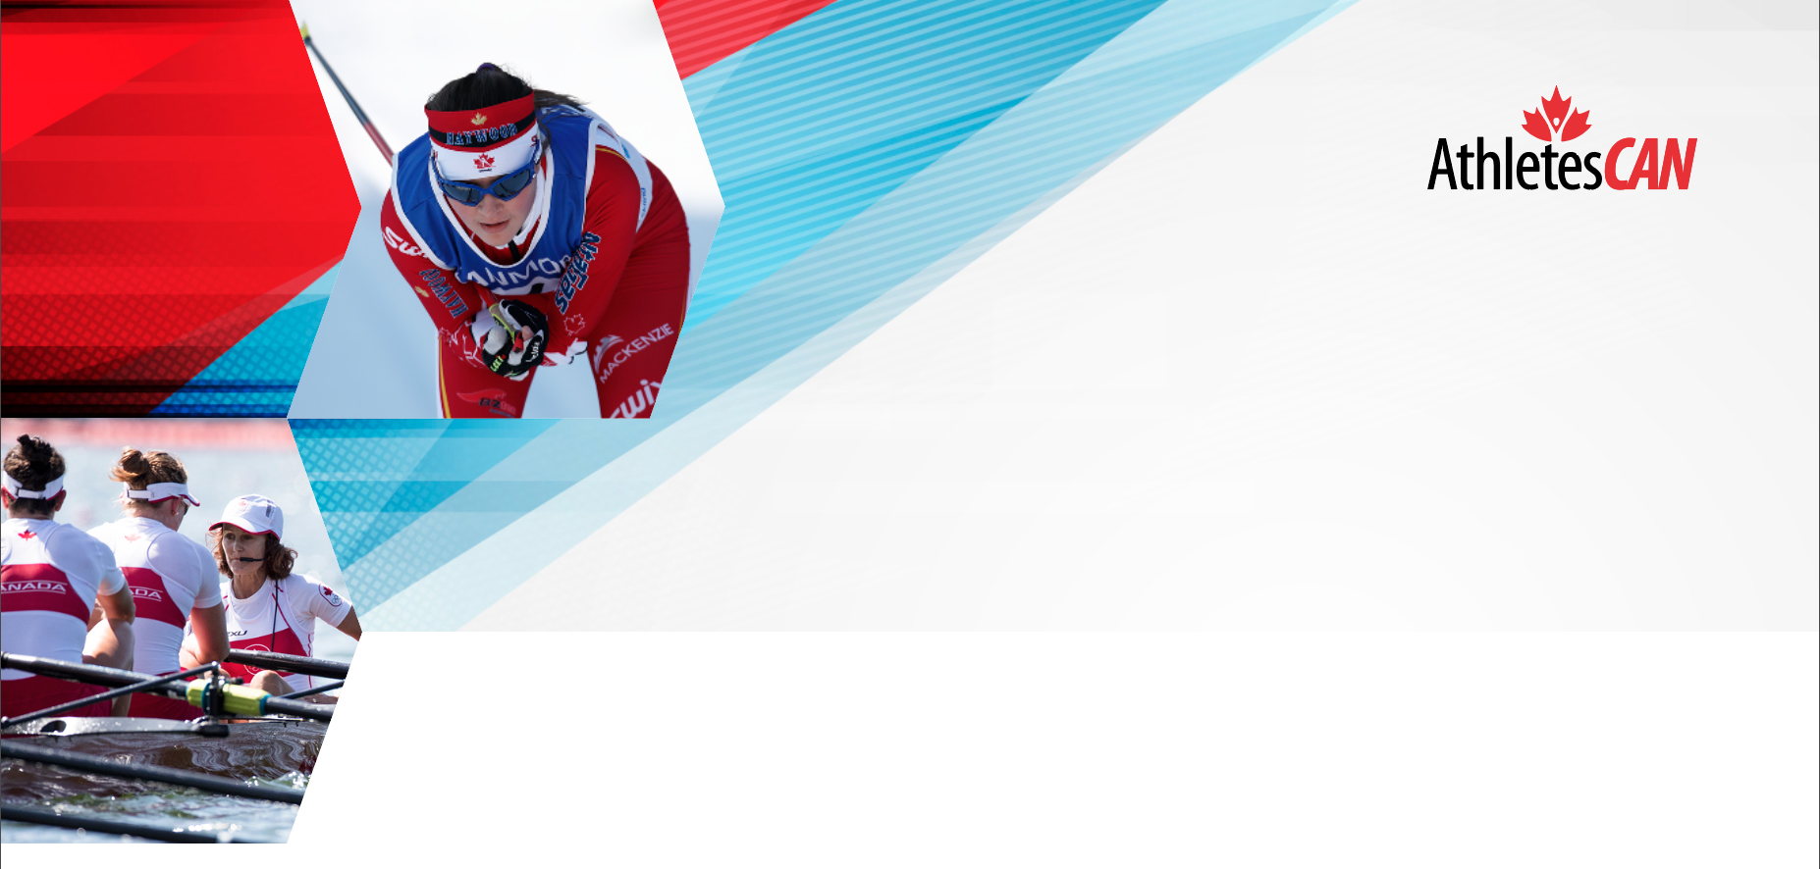

ATHLETE REPRESENTATIVE INTRODUCTORY EMAIL TEMPLATE

Customize the document header image and text

The following template can be used to make an initial connection with the athletes in your sport. It can be tailored to meet your needs and the information you would like to share as a starting off point. It is just one piece of a communication plan that should consist of ongoing, open dialogue between you as the Athlete Representative, the athletes and your National Sport Organization.

Hello fellow athletes!

My name is [YOUR NAME] and I will be your new athlete representative for the next [NUMBER] years. I have been on the national team since [YEAR] and look forward to furthering my involvement in [NSO] with a more hands on approach, as your Athlete Representative. As your Athlete Rep I want to ensure that YOUR VOICE is heard and YOUR RIGHTS are respected.

As your Athlete Rep, my job is to:
• Effect positive change within our sport.
• Learn as much as possible about [NSO] and the Canadian high-performance sport system to better understand and represent your interests and those of our teammates.
• Educate our [NSO] representatives about current athlete needs and the status of the national team effectively.
• Meet and work with other Athlete Representatives from various sports to exchange ideas, network, and strengthen the athlete voice.
• Educate you and our teammates about [NSO]’s strategic plans, policies and procedures, and the high-performance sport system to ensure a level playing field and foster athlete leadership development within our team.

I will represent your voice and strive to ensure our sport is athlete-centered and that the values, programs, policies, resource allocation, and priorities of [NSO] is placing primary emphasis on the consideration of our needs as athletes, both professionally and personally. We should be an active subject, not the object of sporting programs.

As my fellow teammate, I want you to know that I am open to any and all feedback at any time and I will do my best to respond to you within 24 hours with either a recognition, a promise to help, or with a solution/plan of action. The best way to get in contact with me is via [COMMUNICATION PLATFORM] at [USERNAME/ADDRESS]. I encourage you all to join our group chat on [COMMUNICATION PLATFORM] by [ACCESS INSTRUCTIONS] for easier communication.

The only way I can effectively represent the needs of our team is if we all work together. I will make sure to keep you up to date on anything affecting us as athletes. Please always feel free to let me know if you have any questions or concerns.

To get the ball rolling, I would love to hear your feedback on any of the following topics:
→ Athlete Representation/Athlete Communication – what methods of communication do you prefer and find works best with your schedule?
→ Athlete Assistance Program/Carding
→ Athlete Agreements
→ Dispute Resolution
→ Team Selection
→ Communication with our NSOs
→ AthletesCAN – are you familiar with the organization, and do you use their services?

I look forward to working closely with each of you and representing the athlete voice in [NSO] for at least the next [NUMBER] years!

Sincerely,

[NAME]
Athlete Representative

YOUR VOICE MATTERS

